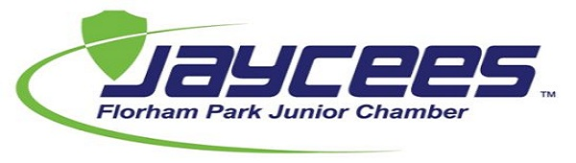
Florham Park Jaycee Scholarship in memory of
Ashley and Billy Streiter
2022-2023 Completed Application should be returned by 5/06/23 to:
Florham Park Jaycees Scholarship Committee, PO Box 2, Florham Park, NJ 07932
Or
fpjaycees@gmail.com
Name:
Address:
Telephone #:
Date of Birth:
Parents Name(s):
Parents Address:
Parents Telephone #:
Name of High School:
Graduation Date:
Grade Point Average:
Class Standing:
Intended Course of Study in College or Technical School:
Please include a copy of your High School Transcript with your Application
Name of College/Technical School Accepted to (please provide letter of acceptance):
Primary School:
1st Alternate School:
2nd Alternate School:

Volunteer Projects/Programs Involved in:

Extra-Curricular Activities (Sports, Clubs, Student Government, Etc.…)

Names, Addresses, Telephone numbers of 3 Adult References (other than relatives):

Application Essays (Please type, print, and attach your responses – 250 words or less) (ANSWER ALL QUESTIONS)
- Describe your most rewarding volunteer experience.
- Describe one or more activities that demonstrate your leadership abilities.
- Describe your most challenging and rewarding experience in High School.
- Tell us why you have chosen your particular field of study.

Signature of Applicant

Signature of Guidance Counselor

